**Gilgit:**

Nanga Parbat

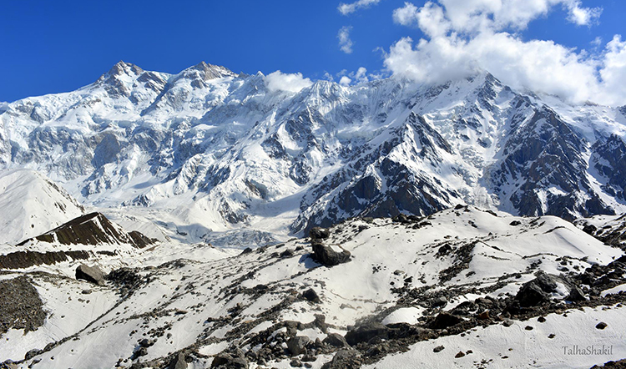

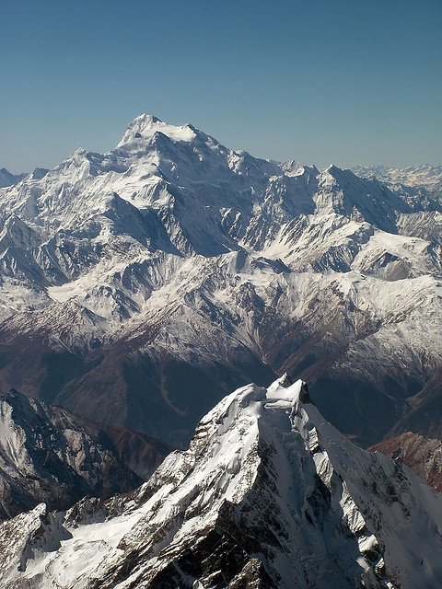

**Nanga Parbat** locally known as **Diamer** , is the ninth highest mountain in the world at 8,126 metres (26,660ft) above sea level. Located in the Diamer District of Pakistan’s Gilgit Baltistan region, Nanga Parbat is the western anchor of the Himalayas. The name Nanga Parbat is derived from the Sanskrit words **nagna** and **parvata** which together mean "Naked Mountain". The mountain is locally known by its Tibetan name **Diamer**or **Deo Mir**, meaning "huge Mountain".Nanga Parbat is one of the eight-thousanders. An immense, dramatic peak rising far above its surrounding terrain, Nanga Parbat is also a notoriously difficult climb. Numerous mountaineering deaths in the mid and early-20th century lent it the nickname "Killer Mountain.”